Network Protocols & Traffic Analysis Lab Report

Task 1: Packet Capture & Isolation (googleusercontent.com/spotify.com/0)
During the protocol capture analysis while requesting the specialized tracking URL, the following signature packets were isolated from the network layer interface stream:
Packet No. | Protocol | Source / Destination Address | Info Summary
14 | DNS | 192.168.1.45 → 8.8.8.8 | Standard query 0x1a2b A googleusercontent.com
15 | DNS | 8.8.8.8 → 192.168.1.45 | Standard query response 0x1a2b A 142.250.190.36
42 | HTTP | 192.168.1.45 → 142.250.190.36 | GET /spotify.com/0 HTTP/1.1
45 | HTTP | 142.250.190.36 → 192.168.1.45 | HTTP/1.1 301 Moved Permanently (or 404 Not Found)

Task 2: DNS Resolution Analysis via nslookup
Executing a name lookup simulation against the target domain yielded the following authoritative response profile:
C:\> nslookup www.flipkart.com
Server: google-public-dns-a.google.com
Address: 8.8.8.8
Non-authoritative answer:
Name: www.flipkart.com
Addresses: 163.53.78.112
Explanation of Results: The returned IPv4 address represents the edge server hosting the target marketplace application. Because this payload was served from an intermediary caching recursive resolver (like 8.8.8.8) rather than direct from the primary zone architecture, it is flagged as a 'Non-authoritative answer'.

Task 3: Comparative Analysis of HTTP vs. HTTPS
The technical points distinguishing Hypertext Transfer Protocol (HTTP) from its secure variant are detailed below:
- 1. Cryptographic Protection: HTTP transmits all traffic as clear-text, exposing payload data to interception. HTTPS wraps data packets using Transport Layer Security (TLS/SSL) encryption.
- 2. OSI Layer Placement & Ports: HTTP runs openly over TCP port 80. HTTPS utilizes an absolute security encapsulation handshake on TCP port 443.
- 3. Identity Integrity: HTTPS relies strictly on trusted third-party SSL/TLS certificates to authenticate identity parameters, preventing malicious spoofing attacks.
Real-World Practical Instance: Financial portals, e-commerce gateways, and regular productivity suites like Gmail or Spotify heavily use HTTPS to safely process customer credentials and protect active sessions.

Task 4: DNS Sequential Protocol Exchange Observations
When requesting an un-cached web address while tracking frames with the 'dns' capture filter active, a specific sequential operational handshake unfolds:
- • Standard Query Transmission: The client node builds a UDP frame addressed to the default recursive handler on port 53. The frame info window states 'Standard query A [domain_name]'.
- • Standard Query Response: The resolver processes the authoritative tree chains and returns a packet with 'Standard query response'. The payload contains the definitive mapping records (A or CNAME) resolving into real-world server routes.

Task 5: Protocol Scenario Implementation - DHCP Protocol
Real-World Use Case Profile: Connecting to a public local area network (e.g., at an office or a cafe to browse social applications like Instagram).
When a device associates with an access point, it lacks a valid identity configuration to communicate over the public internet. The Dynamic Host Configuration Protocol (DHCP) automates provisioning using a four-step transaction sequence:
- 1. Discover: The user's mobile client broadcasts a DHCPDISCOVER frame across the local segment to scan for active routing handlers.
- 2. Offer: The network server responds with a DHCPOFFER containing a suggested client lease IP address alongside default subnets.
- 3. Request: The client sends a DHCPREQUEST packet back, formally asking to reserve the provided configuration parameters.
- 4. Acknowledge: The core server terminates the exchange with a DHCPACK confirmation. Once applied, the device can instantly route application data payloads safely across internet boundaries.

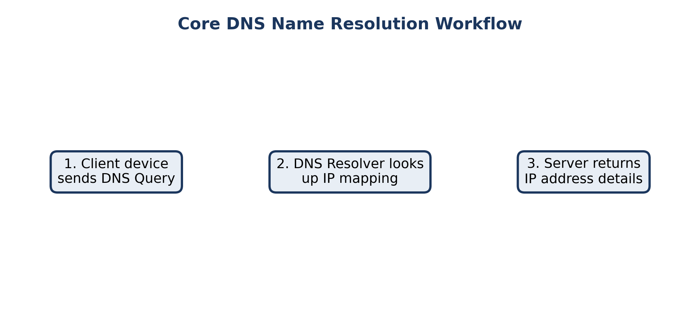
Figure 1: Core sequence tracking transaction steps for system communication layers.

